**Create a simple cloud software application for Mark Sheet Processing System using any Cloud Service Provider to demonstrate SaaS include the necessary fields such as name of the student, Reg no of the student, Subjects , Marks, Average, percentage, rank, overall performance etc.**

**AIM:**

To Create a simple cloud software application for Mark Sheet Processing System using any Cloud Service Provider.

**PROCEDURE:**

**STEP 1:**

Open browser and get into zoho ceator. Then sign in and click “Create application”. Below given screenshot will appear, hear type the application name of your Aim.

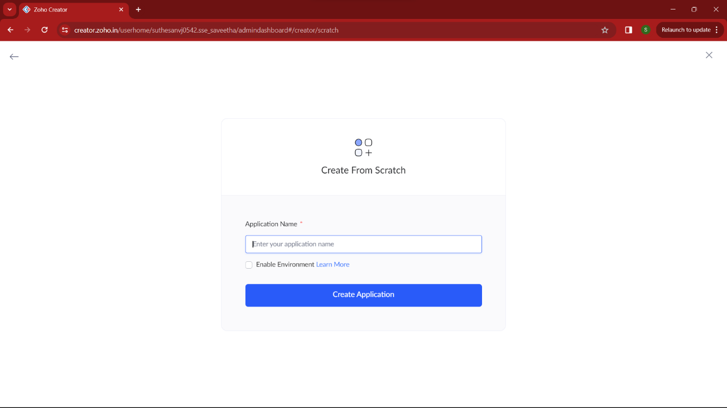

**STEP 2:**

Then select “start from scratch” option and select the proper component from the 4 components listed. For my application I just selected “forms” for the login credentials.

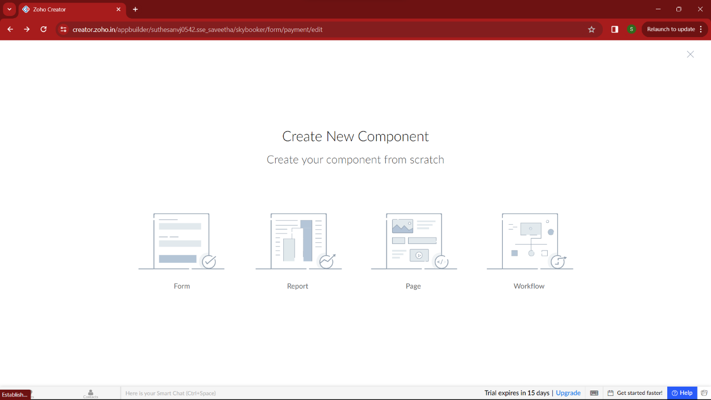

**STEP 3:**

In forms, below given options will be given. From here we can get sample templates of our requirements, otherwise we can import already saved schema for our application. I just selected “ from scratch” option for my application.

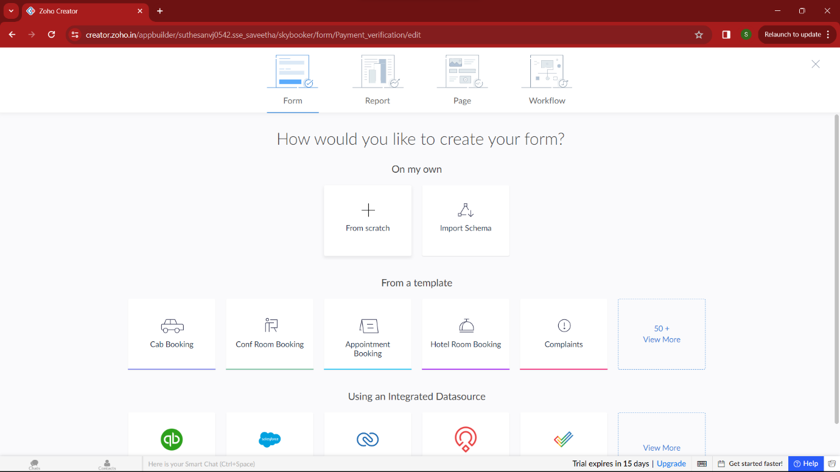

**STEP 4:**

Then provide an appropriate name for our application in the name form which shown below. I gave “GradeGenius” for my “Marksheet processing”

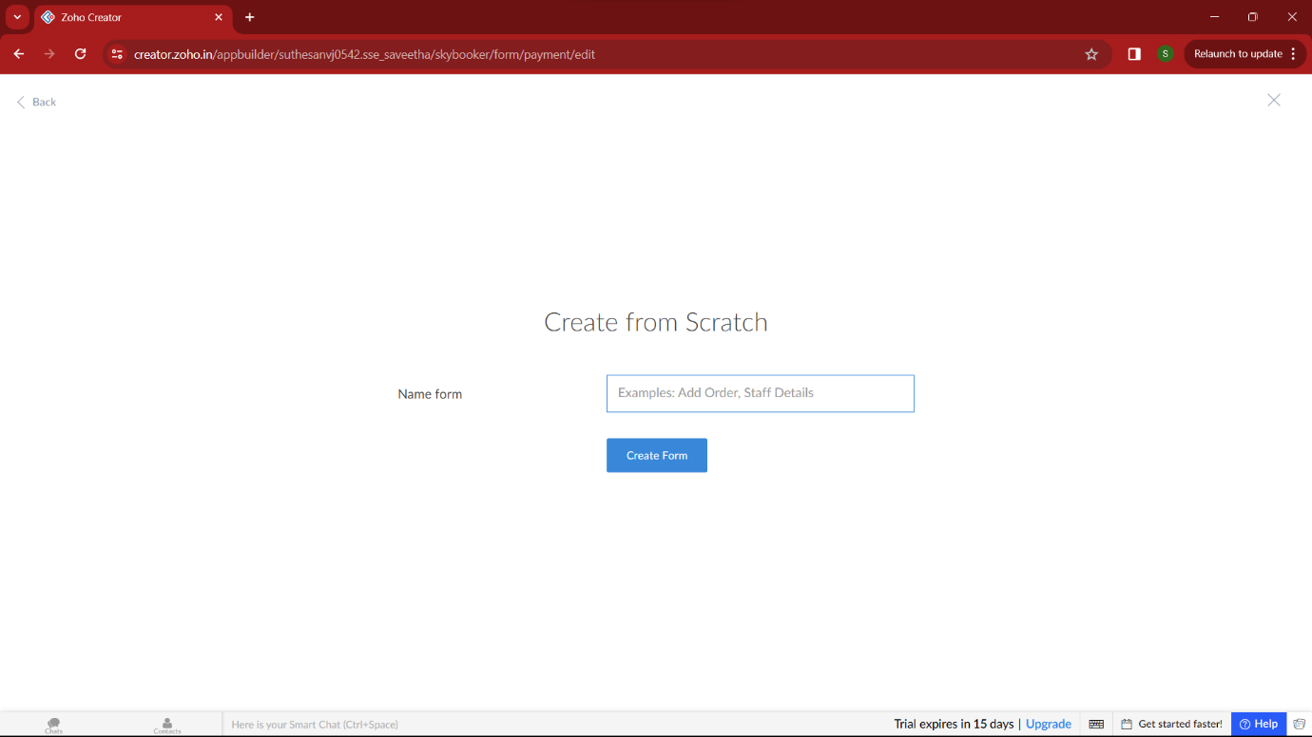

**STEP 5:**

by clicking “+” symbol shown in the picture given below, we can add number of forms in our application. Firstly I placed login form in my application with the essential credent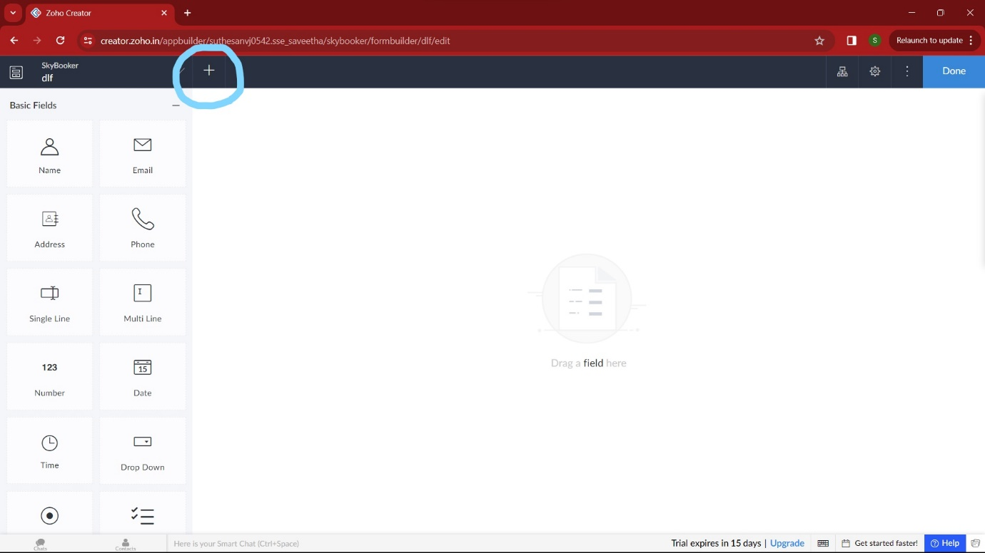

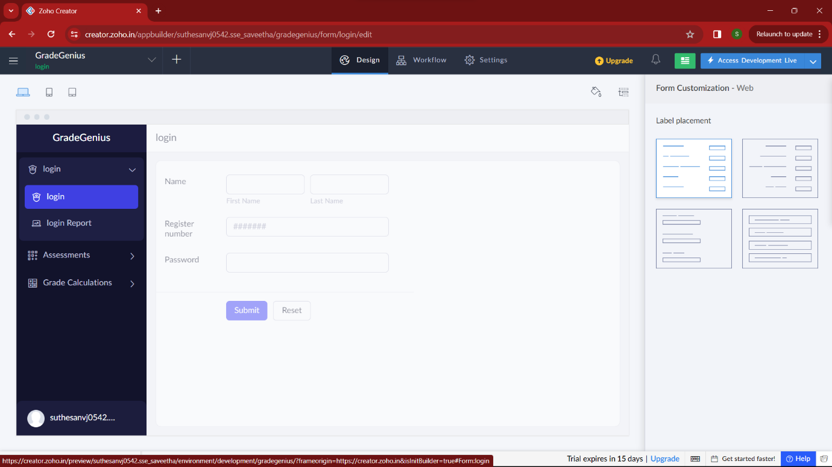

**STEP 7:**

Then I added another form namely “assessments”. It gets all the marks of the stuents for the particular semester.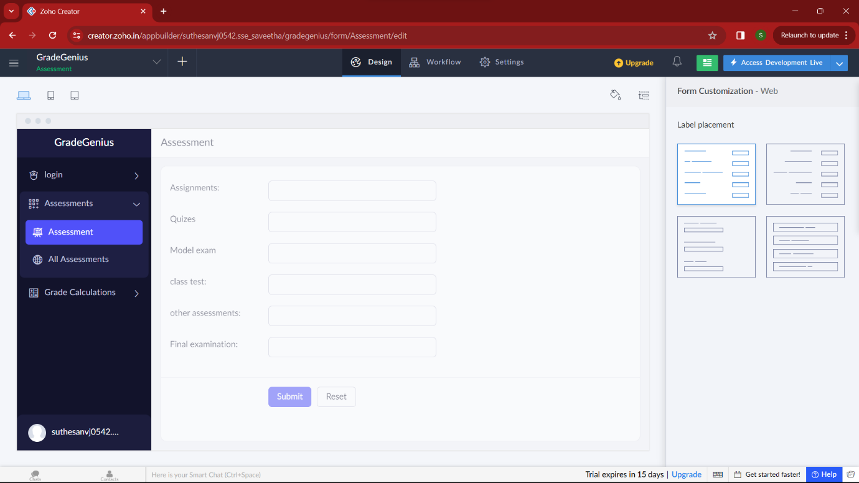

**STEP 8:**

Then I added another form namely “Grade calculation” which calculate the marks and grade and verifies it with the higher officials.by these steps mark sheet is processed. 